**C PROGRAMMING ASSIGNMENT:**

**7**

DATE: 12.11.21

SUBMITTED BY: -

NAME: MUKTESH MISHRA

BRANCH: CSE

SECTION: B22

ROLL NO.: 21052258

***Program 1:***  Write a program to display if 2 lines in 2-d are parallel to each other else any other int value

**Code:**

    return 0;

}

#include<stdio.h>

int main(int argc, char const *argv[])

{

    int x1,x2,x3,x4,y1,y2,y3,y4,m1,m2,t;

    printf("Enter the coordinates of points of (x1,y1) of a line \n");

    scanf("%d %d",&x1,&y1);

    printf("Enter the coordinates (x2,y2) in same line\n");

    scanf("%d %d",&x2,&y2);

    printf("Enter the coordinates (x3,y3) in another line\n");

    scanf("%d %d",&x3,&y3);

    printf("Enter the coordinates (x4,y4) in another line\n");

    scanf("%d %d",&x4,&y4);

    m1=(y2-y1)/(x2-x1);

    m2=(y4-y3)/(x4-x3);

    t=(m1==m2);

    printf("If they are parallel its 1 if not it is 0 \n = %d",t);

}

**Output:**

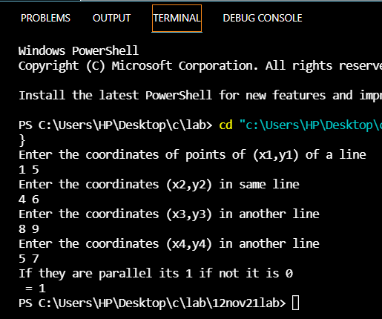

**Program 2:** Write a program to check for right angled triangle.

**Code:**

#include<stdio.h>

#include<math.h>

int main(int argc, char const *argv[])

{

    int p,b,h,t;

    printf("Enter perpendicular side \n");

    scanf("%d",&p);

    printf("Enter hypotenuse side\n");

    scanf("%d",&h);

    printf("Enter base side\n");

    scanf("%d2",&b);

    t=(pow(p,2)+pow(b,2)==pow(h,2));

    printf("If it qualifies for a right angled triangle output is 1 if not it is 0 \n = %d",t);

    return 0;

}

**Output:**

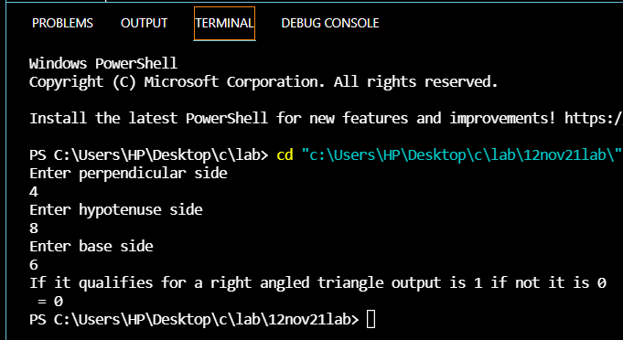

Program 3: write a program to disp time period of a simple pendulum?

**Code:**

#include<stdio.h>

#include<math.h>

#define pi 3.14

#define g 10

int main(int argc, char const *argv[])

{

    int l1,l2,l3,l4,l5; float t1,t2,t3,t4,t5;

    printf("Enter 5 time periods \n");

    scanf("%d %d %d %d %d",&l1,&l2,&l3,&l4,&l5);

    t1=2*pi*sqrt(l1/g);

    t2=2*pi*sqrt(l2/g);

    t3=2*pi*sqrt(l3/g);

    t4=2*pi*sqrt(l4/g);

    t5=2*pi*sqrt(l5/g);

printf("Length     Time period\n");

    printf("%d         %f\n",l1,t1);

    printf("%d         %f\n",l2,t2);

    printf("%d         %f\n",l3,t3);

    printf("%d         %f\n",l4,t4);

    printf("%d         %f\n",l5,t5);

    return 0;

}

**Output:**

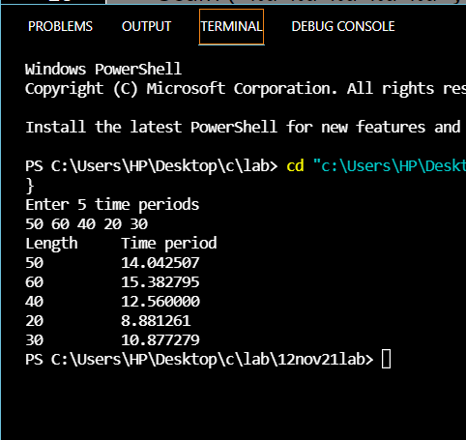

***Program 4:*** Write a program to display 1 if 2 lines in

2-d are perpendicular to each other else any other integer value

**Code:**

#include<stdio.h>

int main(int argc, char const *argv[])

{

    int x1,x2,x3,x4,y1,y2,y3,y4,m1,m2,t;

    printf("Enter the coordinates of points of (x1,y1) of a line \n");

    scanf("%d %d",&x1,&y1);

    printf("Enter the coordinates (x2,y2) in same line\n");

    scanf("%d %d",&x2,&y2);

    printf("Enter the coordinates (x3,y3) in another line\n");

    scanf("%d %d",&x3,&y3);

    printf("Enter the coordinates (x4,y4) in another line\n");

    scanf("%d %d",&x4,&y4);

    m1=(y2-y1)/(x2-x1);

    m2=(y4-y3)/(x4-x3);

    t=(m2*m1*(-1)==1);

    printf("If they are perpendicular its 1 if not it is 0 \n %d",t);

    return 0;

}

**Output:**

